Ouput Of Building A Restaurant Website with Bootstrap.

When We run our program

1.Home Page

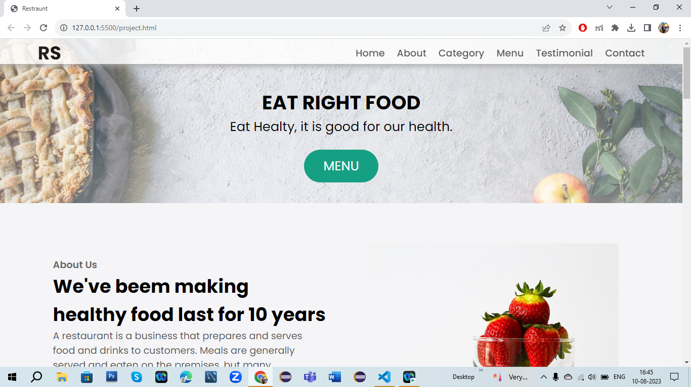

2.Food Menu

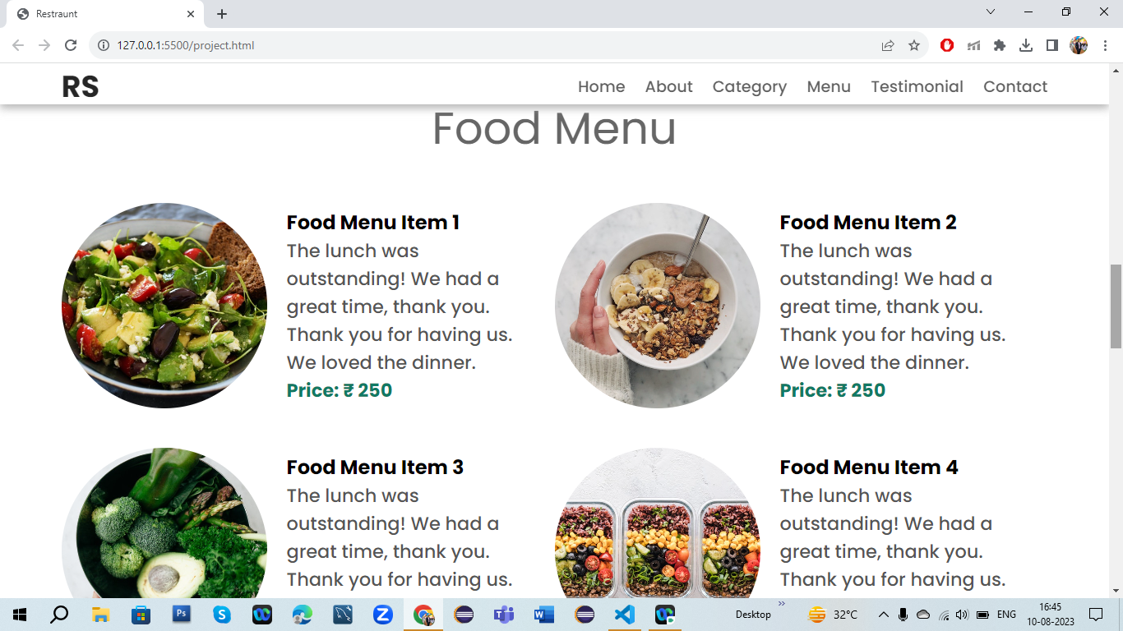

3.Type Of Food

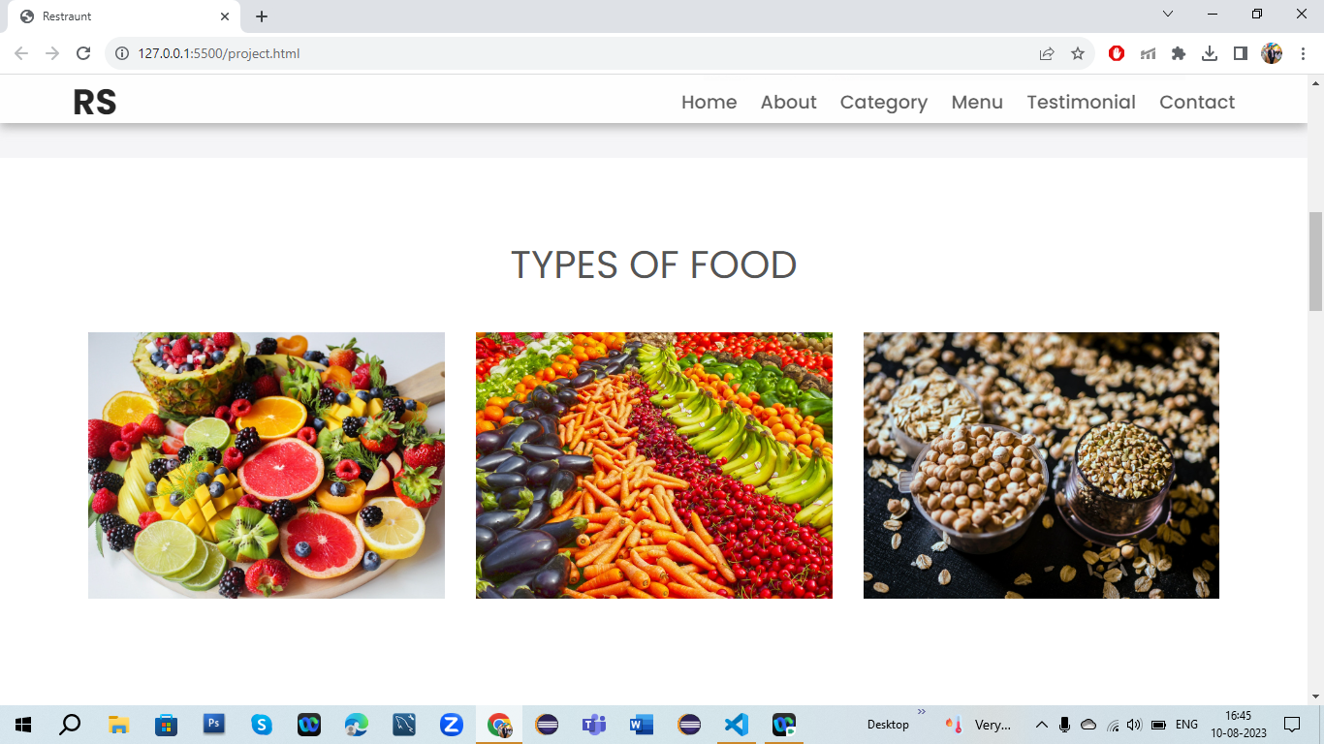

4.About Of Food Quality

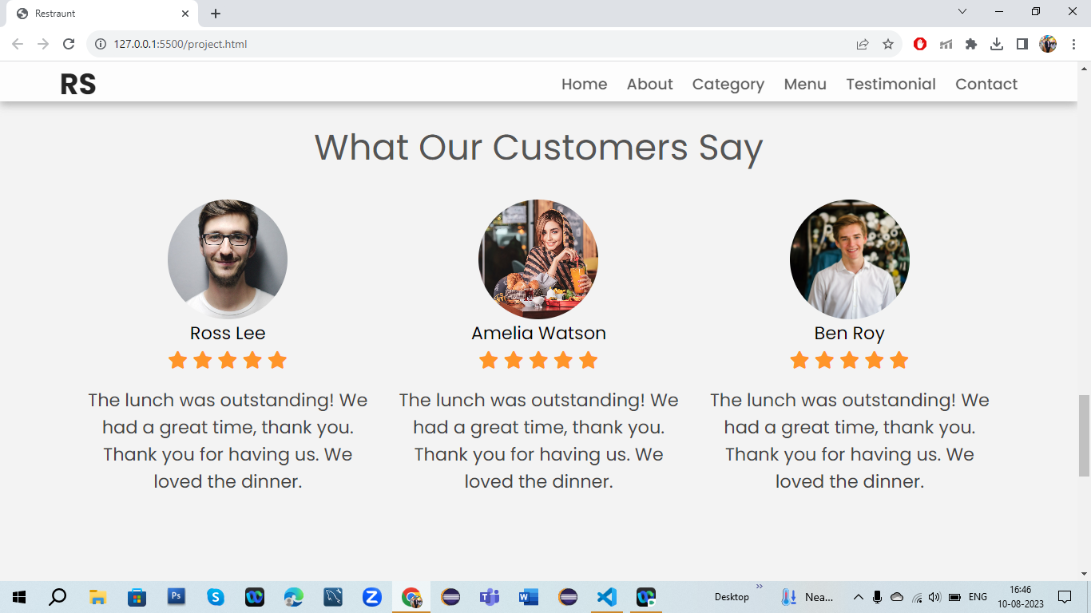

5.Contact From Resturant For Food

